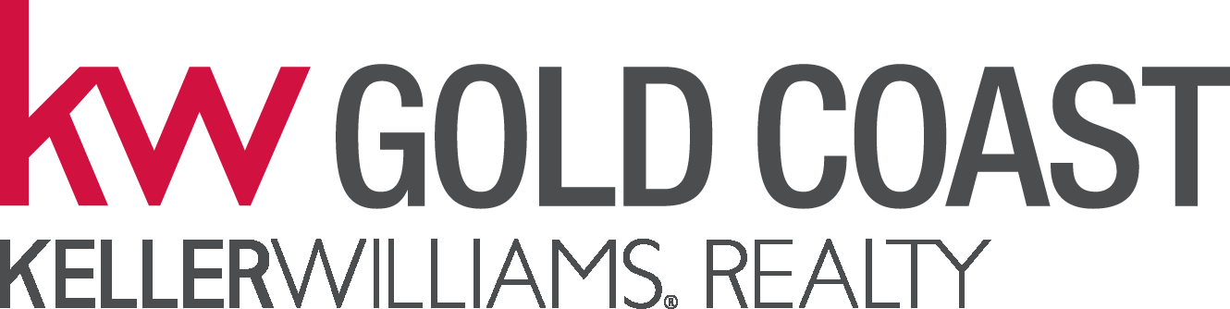
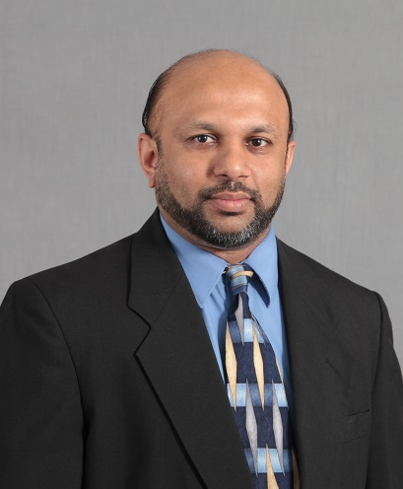
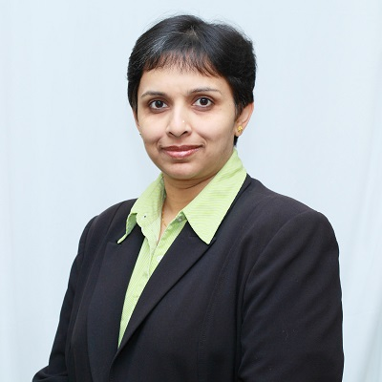
Call us now for a Free Evaluation of your home
C: 646-472-9394
C: 646-472-9393

Integrity & Service Sets Us Apart

THE ALPHA TEAM
at Keller Williams Realty Gold Coast

Keller Williams Realty Gold Coast
1129 Northern Blvd, Suite 410
Manhasset, NY 11030
O: 516-482-0200
F: 516-482-0250
Each Office is Independently Owned and Operated

UMEMA HASSUJI
Real Estate Salesperson
C: 646-472-9394
HASSAN HASSUJI
Real Estate Salesperson
C: 646-472-9393
Email: umemahassuji@yahoo.com
Email: hhassuji@gmail.com
www.umemahassuji.kw.com

If your property is listed with another broker, this is not a solicitation

JUST SOLD

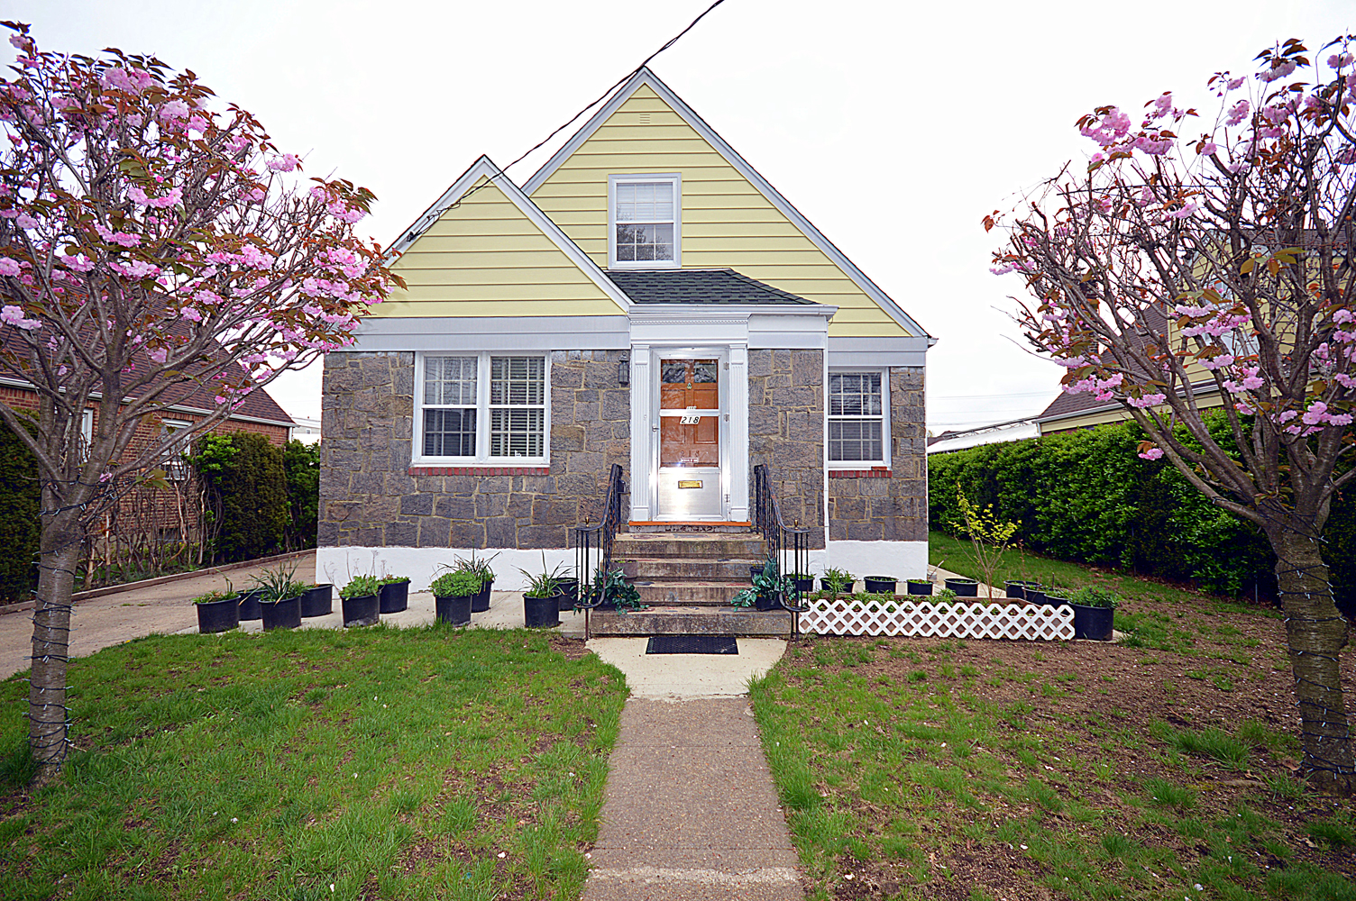
218 Brooklyn Ave,
New Hyde Park,
NY 11040
Asking for $ 579,000
Closed for $ 575,000

